Endpoint

Definition
# Source: AI Source: Provided by: [Data Path: Persons Table -> ID Column: 1, Name_En Column: Motasem Essam] -> From: [ChatGPT] on [7/25/2026]
An endpoint is a point at the end of a geometric object, such as a line segment or a ray.
For a line segment, the two points at its ends are called its endpoints.
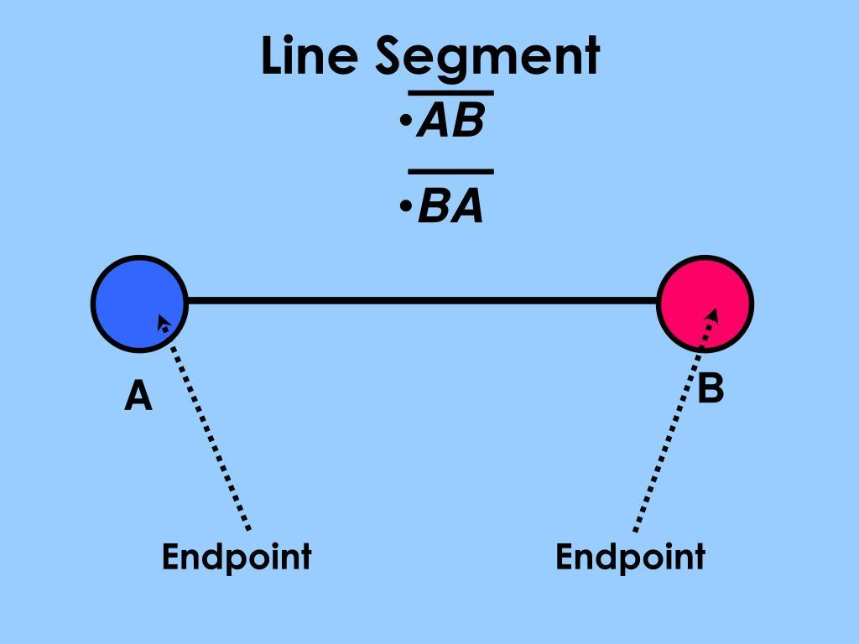
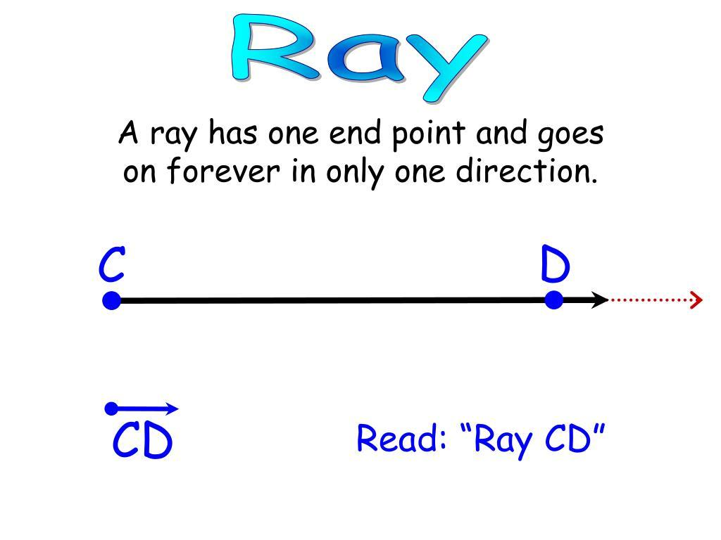
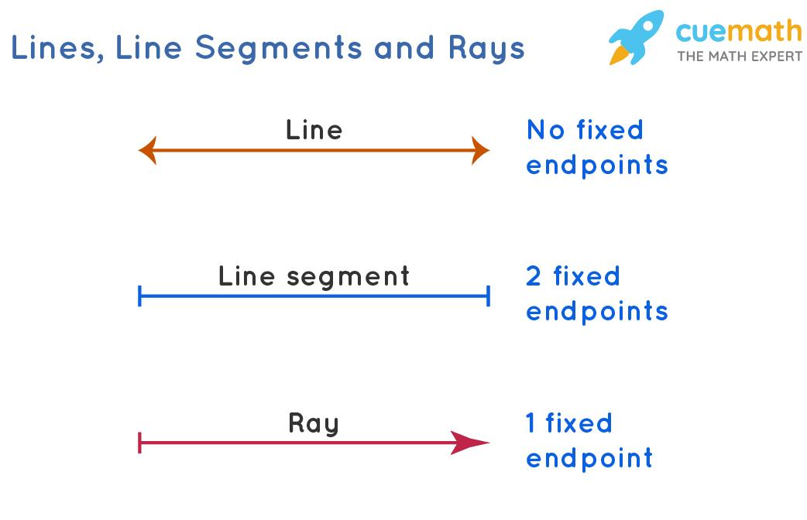
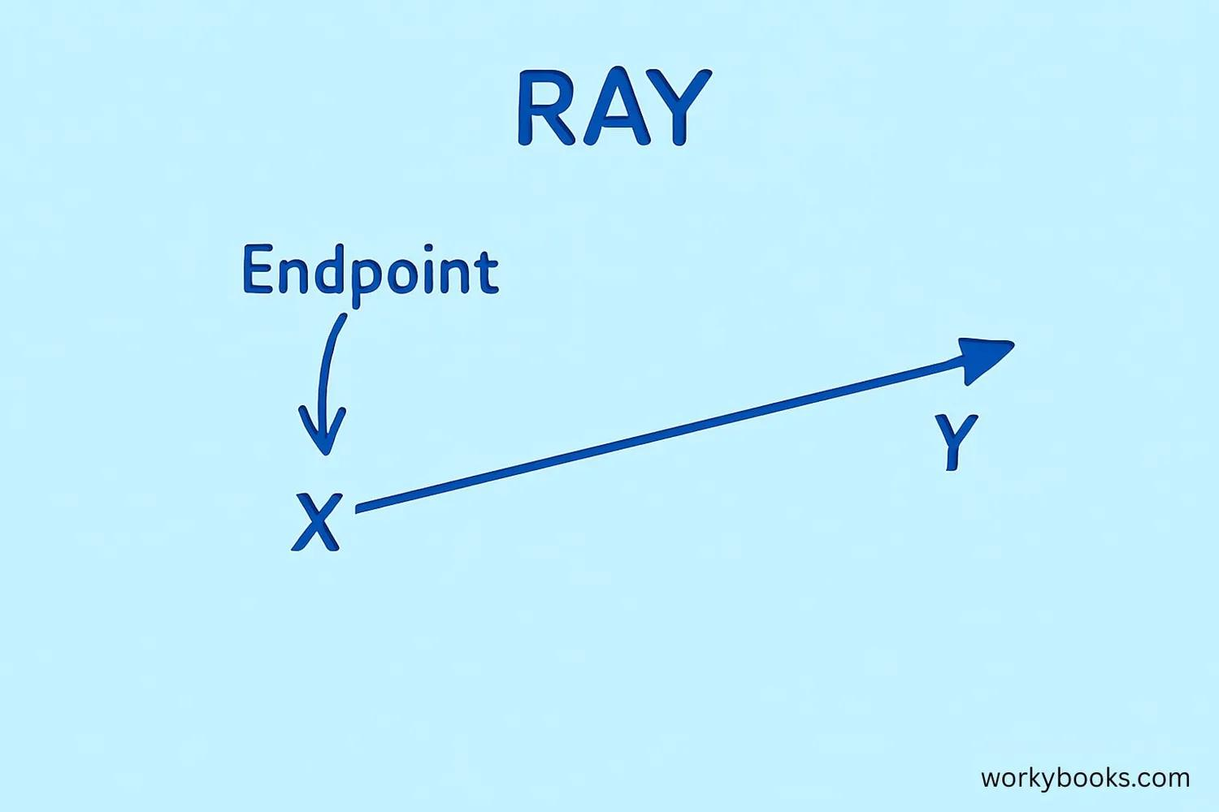
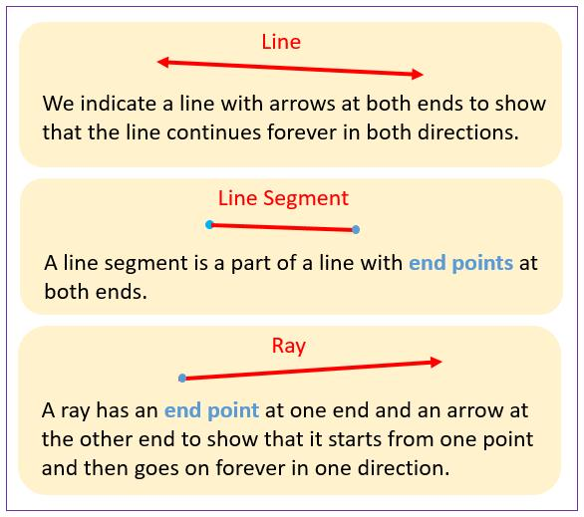
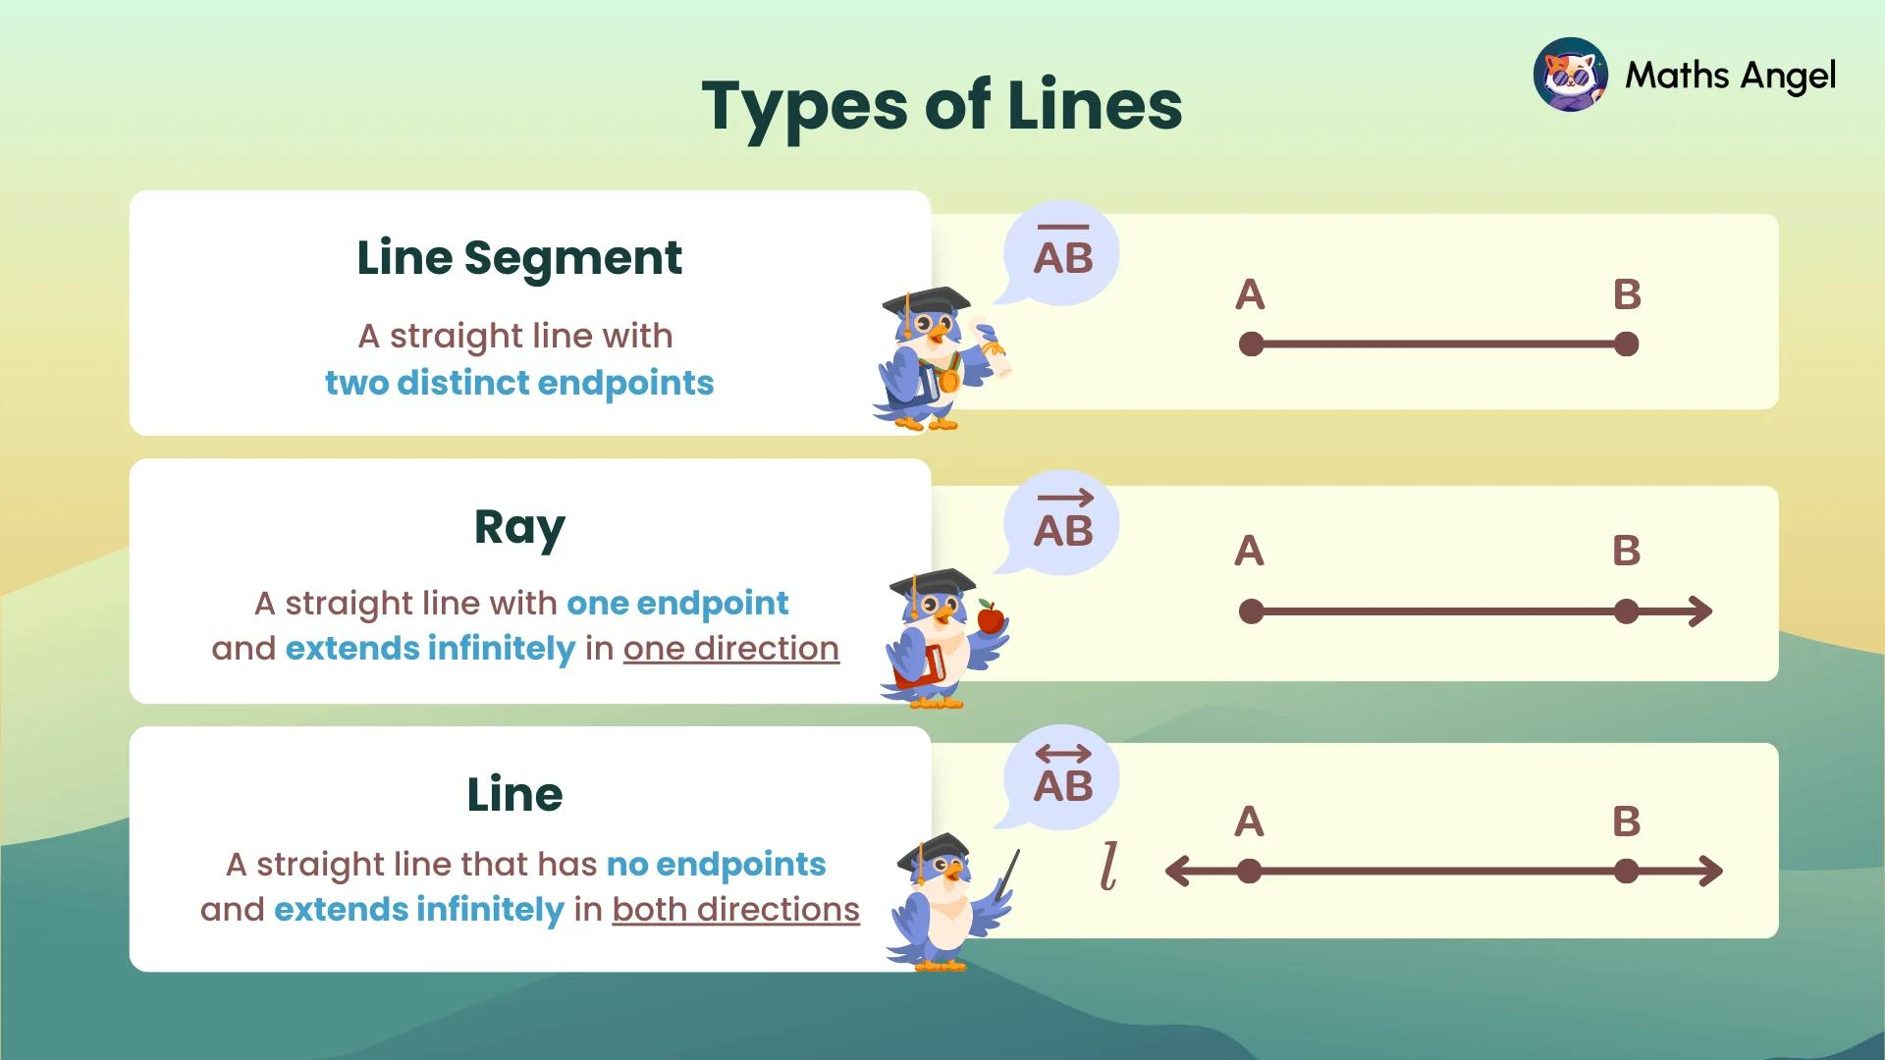
For example, in the line segment
$$\overset{‾}{AB}$$
the points $A$and $B$are its endpoints.

Endpoints of Different Geometric Objects
# Source: AI Source: Provided by: [Data Path: Persons Table -> ID Column: 1, Name_En Column: Motasem Essam] -> From: [ChatGPT] on [7/25/2026]
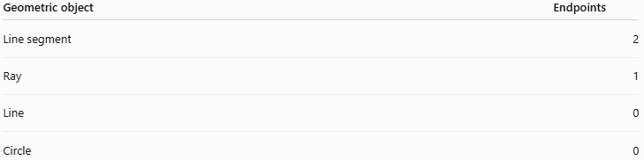
Geometric object | Endpoints
Line segment | 2
Ray | 1
Line | 0
Circle | 0

1. Line Segment
# Source: AI Source: Provided by: [Data Path: Persons Table -> ID Column: 1, Name_En Column: Motasem Essam] -> From: [ChatGPT] on [7/25/2026]
A line segment has two endpoints.
$$A∙⟶∙B$$
The endpoints are:
$$A, B$$
The segment extends only from $A$to $B$.

2. Ray
# Source: AI Source: Provided by: [Data Path: Persons Table -> ID Column: 1, Name_En Column: Motasem Essam] -> From: [ChatGPT] on [7/25/2026]
A ray has one endpoint and extends infinitely in one direction.
$$A∙⟶⟶⟶$$
$A$is the endpoint.
For example:
$$\vec{AB}$$
has endpoint $A$and extends infinitely through $B$.

3. Line
# Source: AI Source: Provided by: [Data Path: Persons Table -> ID Column: 1, Name_En Column: Motasem Essam] -> From: [ChatGPT] on [7/25/2026]
A line extends infinitely in both directions, so it has no endpoints.
$$⟵⟵∙⟶⟶$$
The points shown on the line are not endpoints.

Endpoint vs. Vertex
# Source: AI Source: Provided by: [Data Path: Persons Table -> ID Column: 1, Name_En Column: Motasem Essam] -> From: [ChatGPT] on [7/25/2026]
These terms are related but are not always interchangeable.
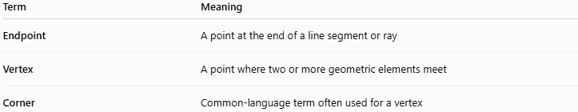
Term | Meaning
Endpoint | A point at the end of a line segment or ray
Vertex | A point where two or more geometric elements meet
Corner | Common-language term often used for a vertex
Example: Triangle
In a triangle, each corner is a vertex:
$$A, B, C$$
Each vertex is also an endpoint of two sides.
For example, $A$is the endpoint of:
$$\overset{‾}{AB}$$
and
$$\overset{‾}{AC}$$
So $A$is a vertex of the triangle and an endpoint of two sides.

Endpoint of a Segment
# Source: AI Source: Provided by: [Data Path: Persons Table -> ID Column: 1, Name_En Column: Motasem Essam] -> From: [ChatGPT] on [7/25/2026]
For a segment
$$\overset{‾}{AB}$$
the endpoints are:
$$\boxed{A\text{ and }B}$$
If its length is $8$units, we can write:
$$AB=8$$
The segment contains every point between $A$and $B$, including its two endpoints.

Endpoint and Segment Addition
# Source: AI Source: Provided by: [Data Path: Persons Table -> ID Column: 1, Name_En Column: Motasem Essam] -> From: [ChatGPT] on [7/25/2026]
Endpoints are particularly important when using the Segment Addition Theorem.
If $B$lies between $A$and $C$:
$$A∙⟶B⟶∙C$$
then:
$$AB+BC=AC$$
Here:
- $A$ and $C$are the endpoints of the larger segment $\overset{‾}{AC}$.
- $B$ is an interior point.
- $A$ is an endpoint of $\overset{‾}{AB}$.
- $B$ is an endpoint of both $\overset{‾}{AB}$and $\overset{‾}{BC}$.
- $C$ is an endpoint of $\overset{‾}{BC}$.

Endpoints of a Polygon
# Source: AI Source: Provided by: [Data Path: Persons Table -> ID Column: 1, Name_En Column: Motasem Essam] -> From: [ChatGPT] on [7/25/2026]
A polygon does not usually have "endpoints" as a whole because it is a closed figure.
Instead, it has vertices.
For example, a square has:
$$4\text{ vertices}$$
and:
$$4\text{ sides}$$
Each side has two endpoints, and those endpoints are vertices of the square.
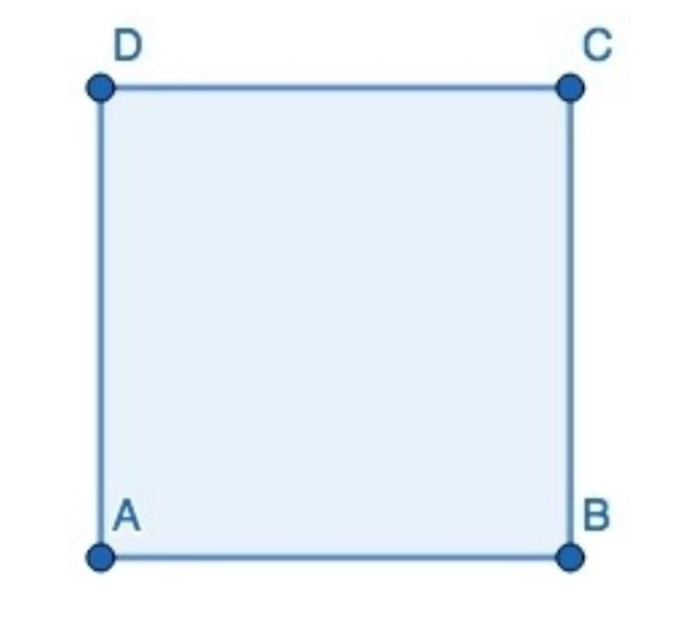
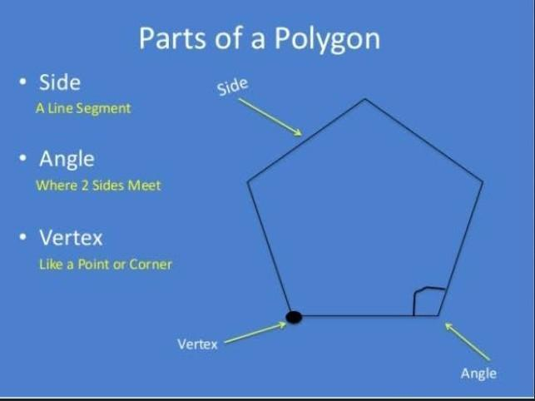
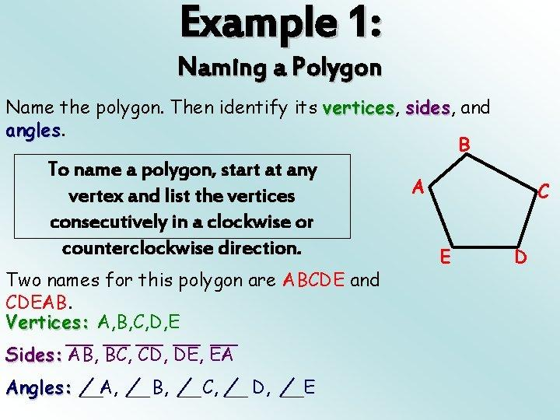
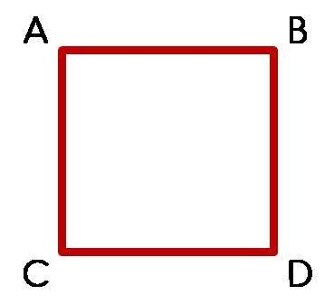
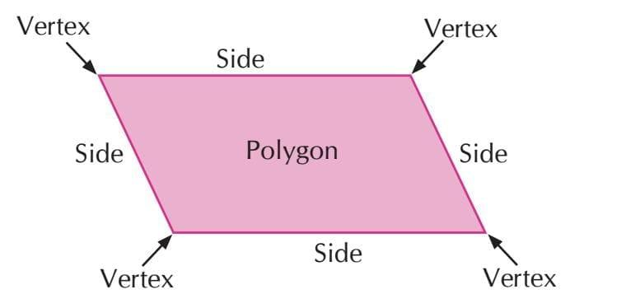

Key Points
# Source: AI Source: Provided by: [Data Path: Persons Table -> ID Column: 1, Name_En Column: Motasem Essam] -> From: [ChatGPT] on [7/25/2026]
- An endpoint is a point at the end of a geometric object.
- A line segment has 2 endpoints.
- A ray has 1 endpoint.
- A line has 0 endpoints.
- The endpoints of $\overset{‾}{AB}$are $A$and $B$.
- A polygon's sides have endpoints, but the polygon itself is normally described using vertices.
- An endpoint can also be a vertex when it is where sides or edges meet.

Conclusion
# Source: AI Source: Provided by: [Data Path: Persons Table -> ID Column: 1, Name_En Column: Motasem Essam] -> From: [ChatGPT] on [7/25/2026]
An endpoint is a fundamental geometric point that marks the end of a segment or ray. The concept is especially important for distinguishing line segments, rays, and lines, and for understanding relationships such as the Segment Addition Theorem.

